

|  |  |  |  |  |  |  |  |  |
| --- | --- | --- | --- | --- | --- | --- | --- | --- |
|  | | | | | | | | |
|  | | Automatic Detection & Removal of Defective parts | | | | |  | |
|  |  | | | | | | |  |
|  | | | |  |  | | | |
|  | | | | ABDELRAHMAN HUSSEINROWAN MOHAMEDMOHAMED ASHRAFREEM MOSTAFA |  | | | |
|  | | | | 27/5/2022—Data acquisition—Eng. Reem Ismael & Nadine Ashery |  | | | |
|  | | |  | | |  | | |



|  |  |  |  |  |  |  |  |  |
| --- | --- | --- | --- | --- | --- | --- | --- | --- |
|  |  | | |  |  | | |  |
|  | SUMMARY | | | | | | |  |
|  |  | | |  |  | | |  |
|  |  | |  | | |  | |  |
|  |  |  | This project involves working in a team to design and build an automated fault detecting & eliminating robotic system to compete with a prevailing obstacle in factory production lines. The system aims to develop a defect free production line. | | |  |  |  |
|  | | | | |
|  |  |  |  |
|  |  |



|  |  |  |  |  |  |  |  |  |
| --- | --- | --- | --- | --- | --- | --- | --- | --- |
|  | |  |  | | |  |  | |
|  | | INTRODUCTION | | | | |  | |
|  | |  |  | | |  |  | |
|  | The objective of this system is to build a gripper arm able to move in 6 directions [up, down, left, right, forward, backward] with an embedded camera to detect faults by shape or color in the production line. The grabbed object should be safely delivered to another shelf under the production line resulting an error free flowing production. | | | | | | |  |
|  | NEEDS/PROBLEM | | |  |  | | |  |
|  | In mass production unreliability and inefficiency in assembly line formed a weak link. Undergoing different preparation steps in the production line may lead to error occurrence and to eliminate this fallacy this project introduces the moving gripper arm. | | |  | This system aims to serve factories of mass production and diminish inconvenience and costly errors in the assembly-line without human interference. | | |  |

##### OBJECTIVES

* The gripper arm should be able to detect errors by both shape and color.
* It should be able to move in 6 different directions [up, down, left, right, forward, backward].
* This automated system should have sensitive estimation of motion.
* Movement should be smoothly moving without vibration

|  |  |  |  |  |  |  |  |  |  |  |  |  |  |  |  |  |  |  |  |  |  |  |  |  |
| --- | --- | --- | --- | --- | --- | --- | --- | --- | --- | --- | --- | --- | --- | --- | --- | --- | --- | --- | --- | --- | --- | --- | --- | --- |
|  | **PROCEDURES/SCOPE OF WORK**   * For image processing a training was made on different shades of same color to develop a good detecting system. * For shape processing, objects of different shapes and sizes were applied to the system. * For shelf balance tests were made on different object weights * Motion sensitivity is critical in the system so trials were made so that the arm gripper is able to reach different spots on the assembly line. * Current regulation is important for the operation of stepper motor, Arduino.   **Time table**   |  |  |  | | --- | --- | --- | | **Phase one** | **Finishing color detecting code** | **Week 8** | | **Phase two** | **Finishing shape detecting code** | **Week 9** | | **Phase three** | **Buying remaining parts** | **Week 10** | | **Phase four** | **3D printing** | **Week 111** | | **Phase five** | **Assembling hardware design and testing** | **Week 12** | | **Phase six** | **Finishing and testing the code for hardware parts using pyfirmata and inking it with openCV code** | **Week 13** | | | | | |  |
|  | |  |  |  |  | |
|  | BUDGET      |  |  | | --- | --- | | Power supply 12v-10A | 270 | | Lead screw nut 8mm | 200 | | Gripper Robotic Arm 2 DOF | 150 | | Jumper Wires | 25 | | Self-Aligning flange bearing(vertical-8mm) | 175 | | Shaft End Support SK8 (Vertical-8mm) | 200 | | 8mm Lead Screw Nut housing  DRV 8825 Motor Driver  Stepper Motor  Coupler  CNC Cutting  Stainless Steel Shafts  Screws  1mm Wires  Plug  Capacitors  Servo | 220  490  400  200  100  150  35  20  15  5  200 |   Total 2855 L.E NEXT STEP  * Making it more ready for dealing with a larger number of products with fast response. * Being more sensitive to color shades and shapes. * Adding the ability to move smoothly in all directions. * Using a more accurate hardware parts as camera to improve efficiency.  APENDIXCircuit: | | | | |  |

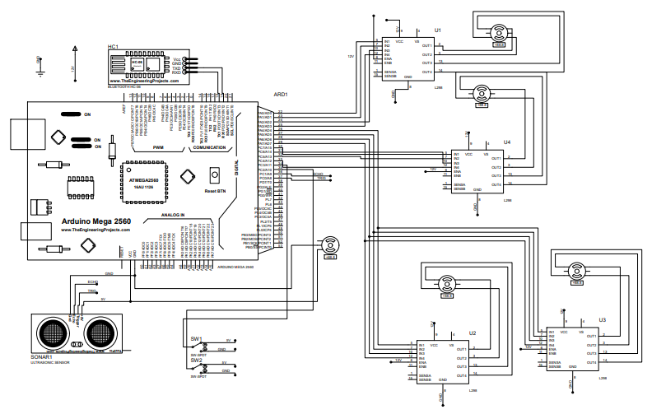

##### Additional references

Color detection:

<https://pyimagesearch.com/2014/08/04/opencv-python-color-detection/>

Motor driver Arduino and Pyfirmata codes:

<https://pyfirmata.readthedocs.io/en/latest/>

<https://realpython.com/arduino-python/>

<https://lastminuteengineers.com/drv8825-stepper-motor-driver-arduino-tutorial/>

<https://docs.arduino.cc/learn/electronics/servo-motors/>

Shape detection:

<https://thinkinfi.com/shape-detection-using-opencv-and-python/>